DEPARTMENT OF **MECHANICAL**



# ENGINEERING

## Senior Highschool

I studied in Hilongos National Vocational School from year 2019 to 2021. I focused more on science, mathematics, and technology, subjects that aligned with my growing interest in engineering. Senior high school provided a deeper understanding of these areas and helped me solidify my career goals. I also became more involved in extracurricular activities, working on group projects and collaborating with others, which strengthened my leadership and teamwork skills.

**Achievements:**

* Graduated as class With Honor
* Consistent honor student from grade 11 to 12
* Elected as Class president

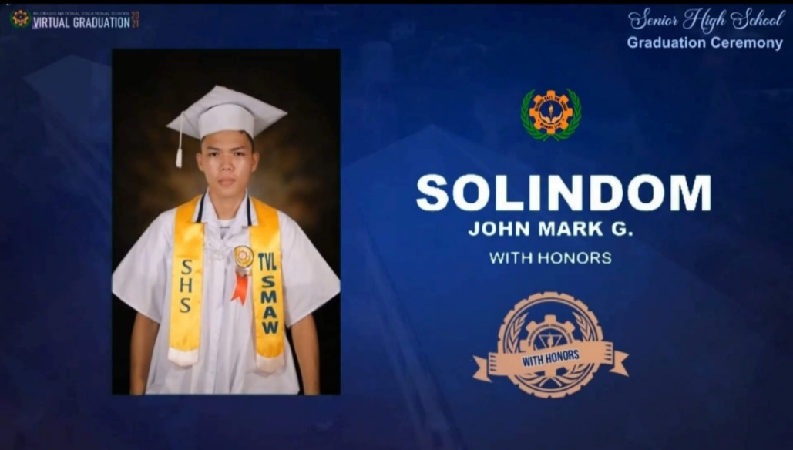

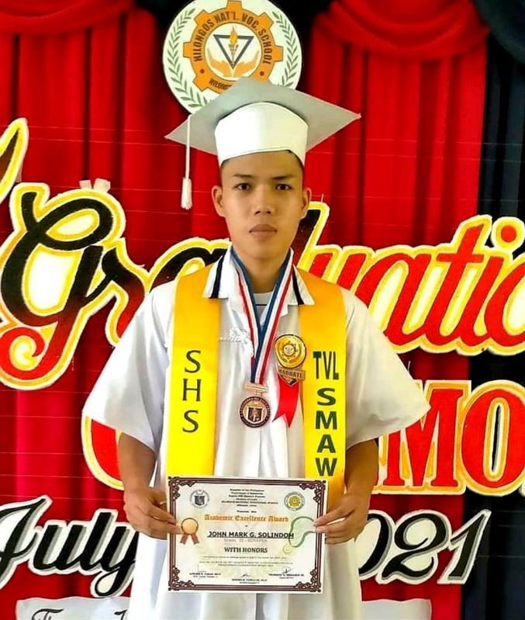

**Experiences:**

* Welding (SMAW)
* 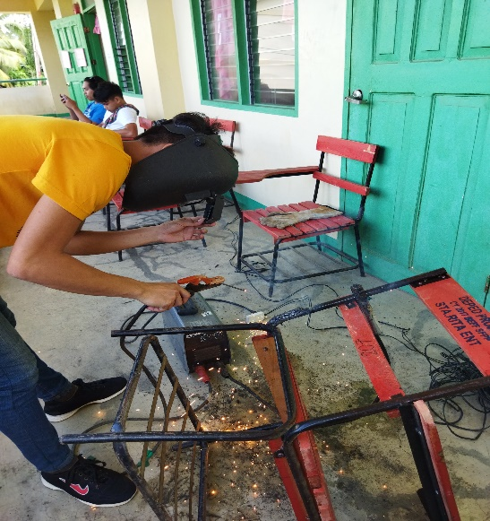Class president

|  |
| --- |
|  |